# Project Title: Movie Recommendation System

**Project Details:**

* The Movie Recommendation machine learning project involves the dataset of 5000 movies.
* For this dataset, preprocessing involves dropping of unwanted features and re-writing of the dataset.
* This project built-up to get recommendation in two ways:

1. Get Recommendations by Genre
2. Get Recommendations by Movie Title

* This project built-up by using Advanced techniques of K-Means Clustering.
* This Project also involves the Case sensitive feature for user input which makes the project user-friendly.

**Challenges & Solutions:**

* **Preprocessing and Feature Extraction:** We faced problem while preprocessing the data, and while deciding about the features for model training.

**Solution:** We dropped all the unnecessary features of the dataset. And we made all the genres as the features of the dataset and started the model training.

* **Classifier selection:** We faced problem while selecting an appropriate

Classifier that could handle the vast and diverse dataset while maintaining computational efficiency.We tried many classifiers like k nearest neighbors and decision trees but got less accuracy.

**Solution:** We followed un-supervised learning and used K-Means clustering to resolve the movies with similar genres into same cluster.

**Team:** K. Madhuri, Y. Madhav.

**Visuals:**

* This project involves basic required GUI only.
* This is designed by using Tkinter.

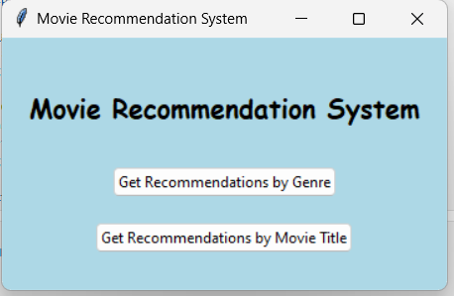

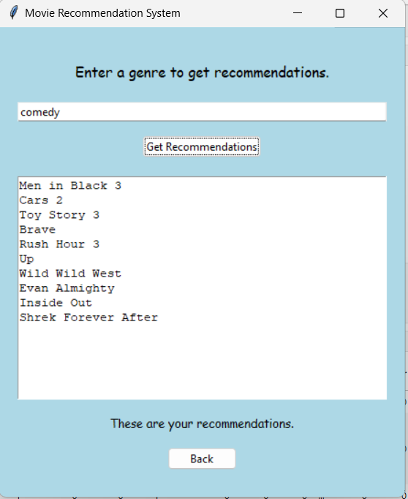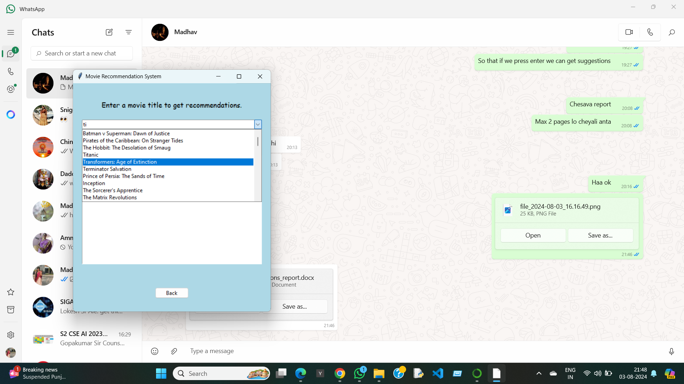

**References:**

* Kaggle: Collection of Dataset.
* Geeks for Geeks.
* Python Documentation of Unsupervised learning,
* Python Documentation of GUI.
* ChatGPT.